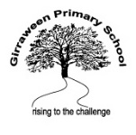
Listening and Speaking at Girraween
Guiding Beliefs
At Girraween, we believe:
- Every child has a voice.
- Oral language skills underpin all literacy learning. Children need to be able to speak and listen before they can successfully read and write.
  - Understand the mechanics of communication
  - Learnt through exposure/immersion to words, speaking, conversations, etc.
- Listening
  - Listen for enjoyment
  - Meaning making
  - Vocabulary acquisition

- Speaking is an articulation of understanding
- Oral language is the link between listening and speaking
- Students will be provided with opportunities to communicate in formal situations for specific audiences
  - Speaking at assembly
  - Oral presentations
  - Sharing learning experiences with the class/peers
- Students will be provided with opportunities to communicate in informal situations
  - Shoulder partner
  - Turn and talk
  - Group work
  - Collaborating (captain collaborative)
- Oral language opportunities will be purposeful but can be both planned and/or spontaneous
  - In a range of contexts
- Demonstrates and develops the Girraween learning powers (Captains Collaborative, Curious, Committed and Creative)
- Children need to be exposed to active modelling of speaking and listening daily
  - Reading aloud
  - Shared reading
  - Giving show and tell
  - Circle time/community circle
  - Engaging in think, pair, share, etc.
  - Giving instructions
  - Checking for understanding

Instructional Practices
Group/Pair work
Practices such as talking partners, think-pair-share, questioning, pick sticks, check in/ check outs, understanding check-ups (Kath Murdoch), class and team building, small and whole group activities promote a culture of oral language, buddy class, not a ‘hands up’ culture
Mat manners/ 5 L’s
Focus on social etiquette; teaching and modelling rules of conversation, thanking guests, listening, manners (5 Ls for Listening)
Play
Provide opportunities for oral language development through play and drama activities.
Song
Drama
Reading & Readers Theatre
Poetry
Students listen to songs, sing and create songs to communicate their ideas.
Inquiry
Inquiry approaches to teaching and learning that encourage all students to be active participants and communicators
Formal speaking
Students are given opportunities to speak formally such as in assemblies, oral class presentation, in school roles such as peer leaders, captains etc
English programs that are oral language rich
Word consciousness, word play, vocabulary building, class meetings opportunities to speak, listen and share daily all contribute to students’ listening and speaking diet
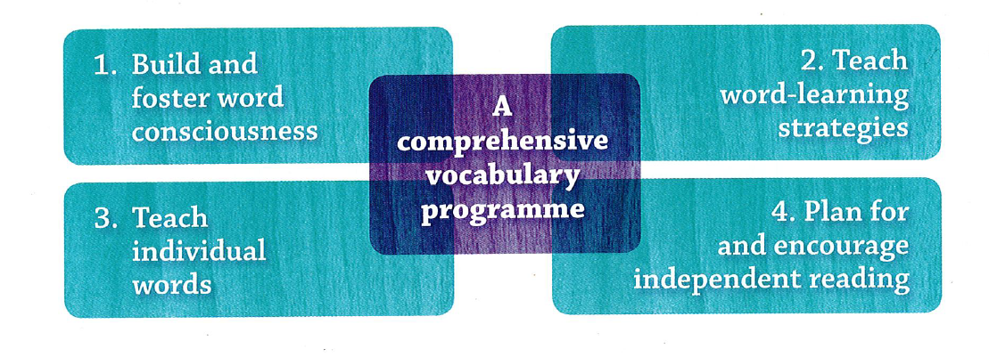

Assessment and Reporting Practices: moving learning forward
We use the Australia Curriculum Listening, Speaking and Interacting continuums to guide our knowledge of where students are at, and our next steps in teaching.
Observation; we observe students’ skills in meaningful and purposeful contexts
Formal Speaking assessments; rubrics, checklists, continuums
FELA; Transition diagnostic assessment

Diagnostic testing and referral where necessary; parent consultation & referral of students who have difficulty with articulation or expressive language, support to work on speech programs
We want to develop:
A community of confident and effective communicators who use purposeful talk in all learning to construct and refine their understandings
An environment that provides plentiful opportunities to develop social, academic and performance language skills
Opportunities for students to practice their performance skills through a range of different experiences in functional and meaningful contexts

We do this by differentiating our programs based on student need:

Resources that support our beliefs and practices
Teacher Reference Materials
Some of the excellent resources available in our library:

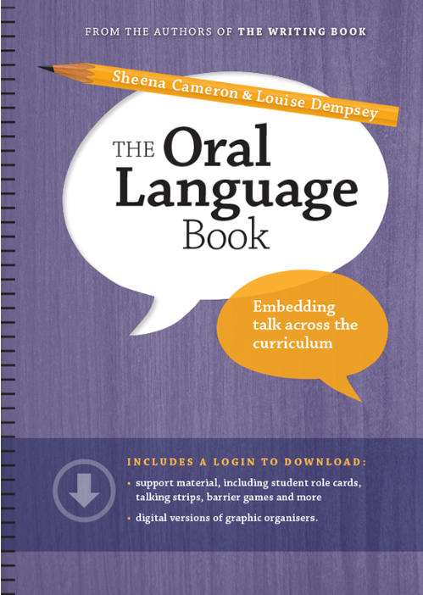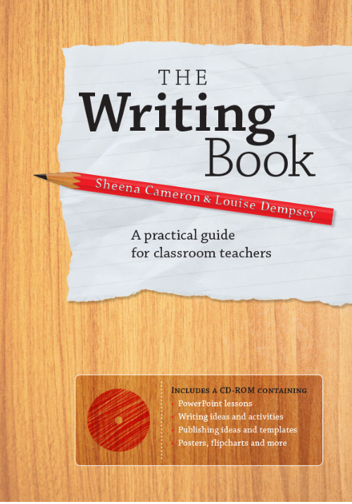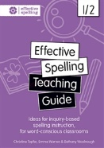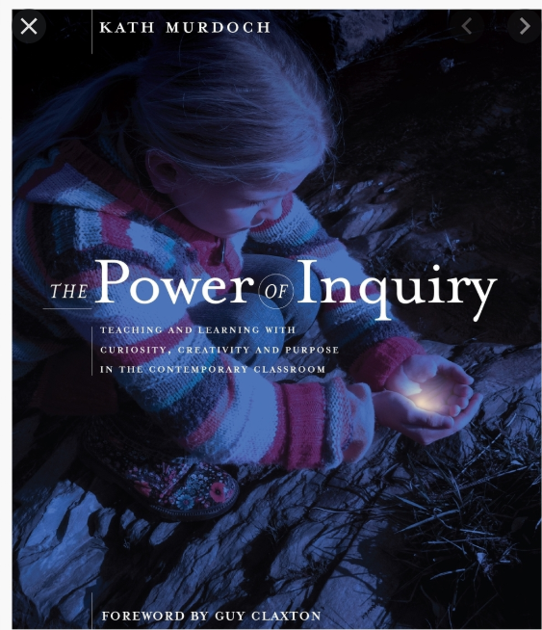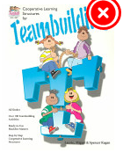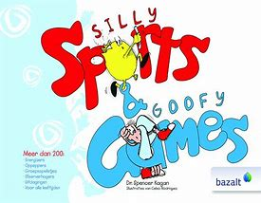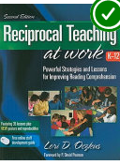
Sheena Cameron Christine Topfer Kath Murdoch Kagan Reciprocal Teaching

Programs: 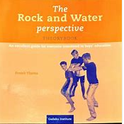 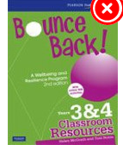
Rock and Water Bounce Back Roybn Ewing Visible Learning- resources?

https://dcurtano.wixsite.com/daniellacurtano Resources designed by Teacher and Speech Pathologist, Daniella Curtano

Exemplar Activities
F-2 | 3-6
Use a rhyming picture story book and ask students to wiggle fingers when a particular rhyming word is heard  Oral close activities  Barrier games. Students work with a partner and sit back to back. One person draws a picture or builds a construction using blocks or makes a creation using modelling clay, while giving instructions to their partner who tries to create the same, with only the use of oral language as a resource  Spot it. Students work with a partner and a detailed picture. Partners take turns at using positional language to describe where to find something on the page  Oral coding activities. Use Bee-bots (or similar coding robots). Partners dictate oral codes to each other to use when programming the robots. | - Dictation relays. Students work in relay teams. First runners run to the front of the room. Read a part of a script and run back to tell the team, who record what is said. The next runner then runs to collect the next section of information. The words must be recorded exactly.  - Oral and written paraphrasing  - Formulating and answering questions  - Three minutes. Three statements. Three turns. Students make groups of three. The teacher provides three statements relevant to the class’s current learning, read out one at a time. Students each speak about the given sentence for one minute. Each student has a turn at being first, second and third to speak  - Play ‘Would you rather…?” and explain why. For example: Would you rather have a day off school or a sleepover at school?  - Listen for the difference. Read a passage to students. Re-read the passage with some minor changes. Students identify the changes  Use a listening text to focus on comprehension.
Programming Expectations
- Start with the Australian Curriculum Learning Progressions – what students need to know and be able to do
- Speaking and Listening links apparent throughout Teaching and Learning Programs (cross curricula)
- Diagnostic and formative assessments that inform teaching and learning of listening and speaking
- Differentiation through task design, assessment to cater for different needs of students

Developed by Girraween Staff 2020

